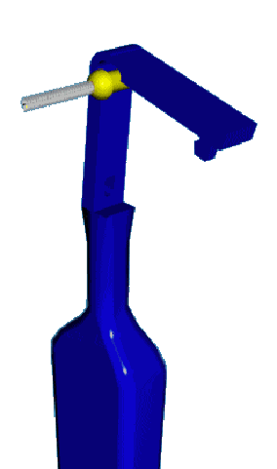
PROXIMAL BRUSHING

Q What is a Proximal brush?

A It is a device in two parts. One part is the handle that has been developed from a standard toothbrush so that it holds a small brush head securely. The brush heads are available in various sizes enabling you to choose which size is most suitable for you. These colours are exactly the same as those used in the interdental brush range.

Q Will I need to use more than one size of brush head?

A You may need to use more than one size to enable you to effectively clean all spaces between your teeth.

Q Will I need to use this brush as well as the interdental brushes?

A The proximal brush can be used in all areas of the mouth. However most people find that it is most useful for cleaning between the back teeth.

Q Why clean between teeth?

A Over the course of a day, food and debris get lodged in between your teeth, and in any gaps you may have. If left, this debris can cause dental decay and gum disease. Removing

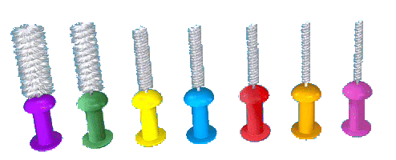
food debris with a proximal brush will help keep your breath fresh. Cleaning in between your teeth ensures that you are cleaning your mouth as thoroughly as possible.

Q Should I use a proximal brush instead of my normal toothbrush?

A No. This brush should be used as part of your normal oral hygiene routine to be effective.

Q Why is my normal toothbrush not enough?

A You will know that there are certain places in your mouth that are difficult to reach with your normal brush. There are also some gaps between your teeth that your toothbrush will not be able to access.

Q How can the proximal brush help?

A With its small filaments and tiny head the brush can be moved between the teeth to remove debris and plaque that will not have been removed by your usual toothbrush, especially at the back of the mouth.

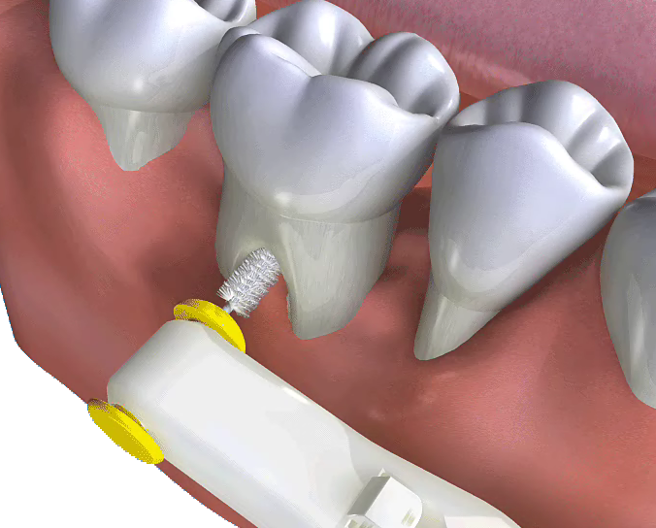
Q How do I use it?

A Select a suitable sized brush head and lock it in place in the handle. You may need a variety of sizes for the spaces at the back of the mouth. Your dentist or hygienist will be able to guide you on which ones to select. Never force the brush between the teeth. Remove the brush gently removing plaque and debris. Always rinse the brush in clean water during and after use.

Q When should I use it?

A You need to clean between all your teeth once a day.

